RICE PAPER WRAPS WITH CHICKEN AND PEANUT DIPPING SAUCE

Makes 4 Rolls
1 Roll | 4 Rolls | Ingredient
1 each | 4 each | Rice Paper Wraps, round, 8”, Spring Roll/Rice Wrapper
¼ cup | 1 cup | Zoodles, Zucchini Spiral Noodles
4 each | 16 each | Red Pepper Strips, sliced thin
4 each | 16 each | English Seedless Cucumber Strips, sliced into thin strips
1 Tbsp. | ¼ cup | Shredded Carrots
1 each | 4 Sprigs | Choice of Fresh Herbs: basil, cilantro or mint
¼ cup | 1 cup | Spring Mix Lettuce, packed, torn into smaller pieces
4 -6 oz | about 1 cup | Chicken Breast, cooked, sliced thin
1 Tbsp | 2 Tbsp | Hoisin Sauce
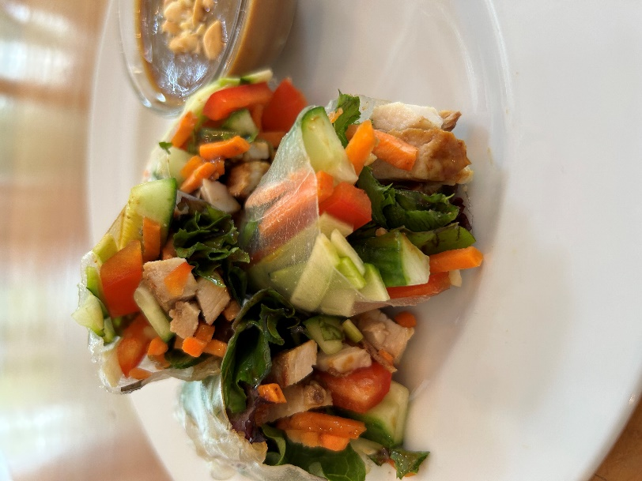
PEANUT DIPPING SAUCE RECIPE:
2 Tbsp Peanut Butter, creamy, natural
2 Tbsp Hoisin Sauce
2 Tbsp Water
1 Tbsp Chopped Salted Peanuts
1/2 tsp Siracha sauce, optional
TO MAKE PEANUT DIPPING SAUCE:
- Place peanut butter, hoisin sauce and water in small bowl.
- Using a wire whisk, mix well.
- Place in small serving bowl and top with chopped peanuts.
TO MAKE 1 ROLL:
- Fill a bowl or pan, slightly bigger than the wraps, with 1” of warm tap water.
- Have all the ingredients ready and work quickly.
- To prepare a wrap, soak 1 wrap in warm water for a few seconds or until the wrap begins to become soft and flexible.
- Remove from water and place on large dry plate.
- Working quickly, place ingredients in order listed, across the middle of the wrap, going from 1 side to the other in a straight line.
- Cover ingredients with ½ Tbsp. hoisin sauce.
- Carefully fold the bottom 2-inch border of the wrapper over the filling. Then fold the left side inward then the right side inward over filling.
- Roll filling as tight as possible to the top edge to seal close.
- Repeat each step to make 4 rolls. Serve with dipping sauce.

